

100 DAYS RTL PART-1

Day 51: GREATEST COMMON DIVIDER USING FSM

Day 52: SINGLE PORT RAM

Day 53: DUAL PORT RAM

Day 54: CLOCK BUFFER

Day 55: SYNCHRONOUS FIFO

Day 56: PRIORITY ENCODER

Day 57: N-BIT COMPARATOR

Day 58: SEVEN SIGMENT DISPLAY USING ROM

Day 59: FIXED PRIORITY ARBITER

Day 60: ROUND ROBIN ARBITER

Day 51: Greatest Common Divider Using FSM
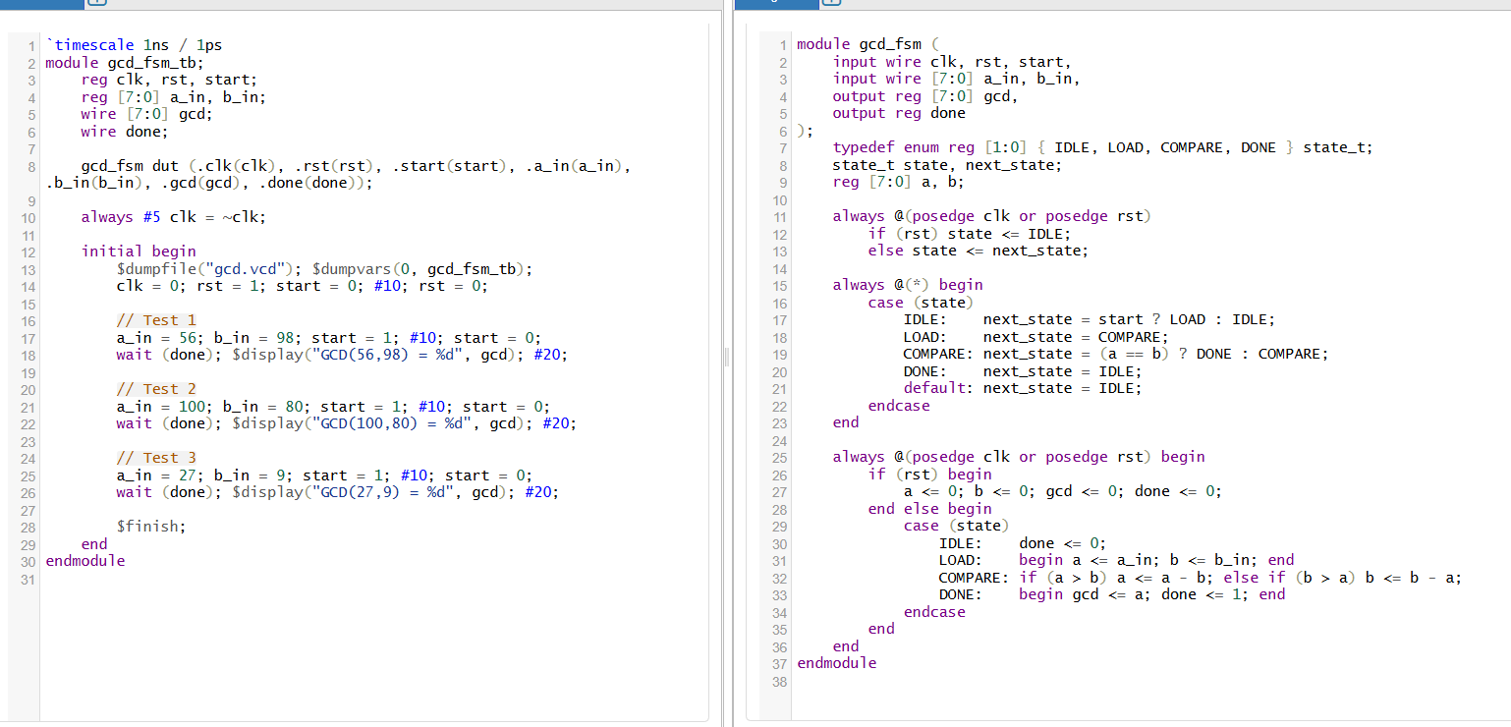
output
GCD of 56 and 98 = 14
GCD of 100 and 80 = 20
GCD of 27 and 9 = 9
💡 Objective:
To find the Greatest Common Divisor (GCD) of two 8-bit numbers using the Euclidean subtraction method implemented via a Finite State Machine (FSM).
🧠 Concept Used:
The Euclidean Algorithm (subtraction method):
- Given two numbers a and b, the GCD is calculated by repeatedly subtracting the smaller number from the larger:
  - If a > b, do a = a - b.
  - If b > a, do b = b - a.
  - Continue until a == b. At that point, GCD = a = b.

⚙️ FSM States Explanation:
We define 4 states for the FSM:
1. IDLE:
- Purpose: Wait for the start signal.
- Action: Do nothing until start becomes 1.
2. LOAD:
- Purpose: Load the input values a_in and b_in into internal registers a and b.
- Action: Assign a = a_in, b = b_in.
3. COMPARE:
- Purpose: Perform the GCD algorithm logic using subtraction.
- Action:
  - If a > b: subtract b from a.
  - If b > a: subtract a from b.
  - Repeat until a == b.
4. DONE:
- Purpose: Output the result (GCD) and raise the done flag.
- Action: When a == b, assign gcd = a and set done = 1.

🔁 FSM Transitions:
Current State | Input Condition | Next State
IDLE | start = 1 | LOAD
LOAD | always | COMPARE
COMPARE | a == b | DONE
COMPARE | a ≠ b | COMPARE
DONE | always | IDLE

🛠 Working Flow Example:
Let’s say a_in = 56, b_in = 98.
- LOAD: a = 56, b = 98.
- COMPARE:
  - b > a → b = b - a → b = 42
  - b > a → b = b - a → b = -14 (repeat until a == b)
- When a == b = 14, DONE state is reached and gcd = 14.

Day 52: Single Port Ram

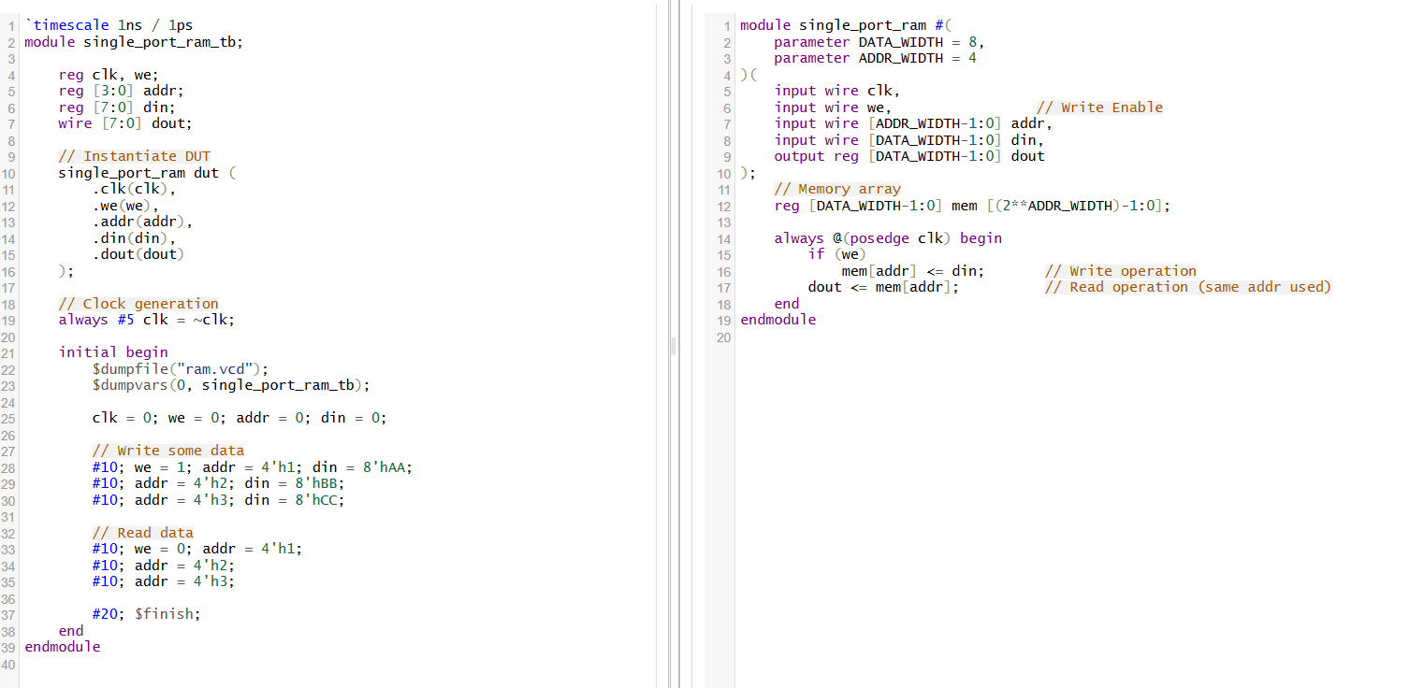
clk cs we oe addr data
0 0 0 0 000 000
1 0 0 0 001 005
0 0 1 0 001 005
1 0 1 0 002 010
📘 What is Single Port RAM?
A Single Port RAM is a memory that:
- Has one address/data port
- Allows either read or write, but not both at the same time
- Uses the same clock for controlling both operations
It is commonly used in simple embedded systems or hardware accelerators where memory access is not concurrent.

⚙️ Components of the Design:
1. Parameters
- DATA_WIDTH: Width of each memory word (e.g., 8 bits)
- ADDR_WIDTH: Number of address bits (e.g., 4 bits for 16 locations)
2. Inputs
- clk: Clock signal (synchronous operation)
- we: Write Enable (when 1, write to RAM; when 0, read from RAM)
- addr: Address of the memory location to read or write
- din: Input data to be written (used during write operation)
3. Output
- dout: Data output (used during read operation)

🧠 How It Works
✅ Write Operation (when we = 1)
- On rising edge of clk, the input din is written into memory at the location addr.
- At the same clock edge, the dout will show the value at that address, which may reflect the new value depending on synthesis behavior.
✅ Read Operation (when we = 0)
- On rising edge of clk, the data stored at addr is placed on dout.
Day 53: Dual Port Ram
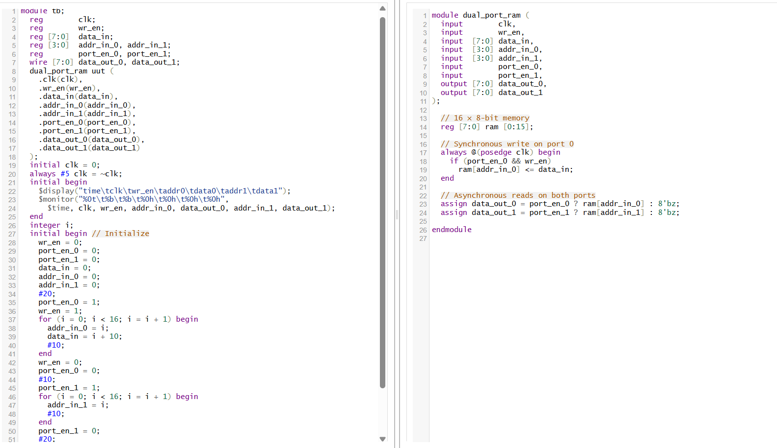
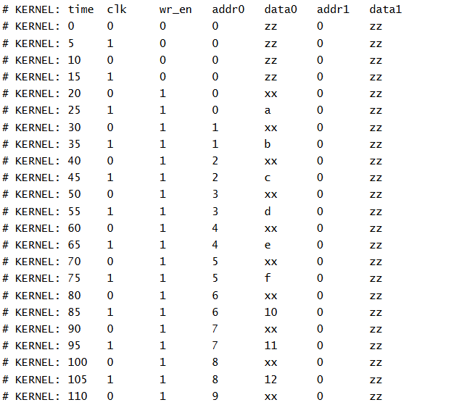
🧠 Core Concepts of Dual-Port RAM
- What is Dual-Port RAM?
A memory with two independent access ports, typically allowing one port to write and the other to read simultaneously. True dual-port memory even permits both ports to write or read at distinct addresses at the same time
- Synchronous vs. Asynchronous Access
  - Synchronous RAM uses a clock for all operations—read and write happen on clock edges, enabling higher speeds through pipelining and predictable timing.
  - Asynchronous RAM updates outputs immediately based on address changes, regardless of the clock—simpler but slower and less scalable .
- Port Structure in Your Verilog Code
  - Port 0 is a write/read port: on each rising clock edge, if we0 (write-enable) is high, it writes din0 into ram[addr0].
  - Port 1 is read-only: it continuously outputs ram[addr1] based on the current address.
  - Both outputs (dout0, dout1) are asynchronous, reflecting memory contents immediately when the address changes.
- Simultaneous Access
Your design supports concurrent operations, e.g., writing to one address on port 0 while reading from another via port 1. As long as they target different addresses, there’s no conflit.

- If both ports access the same address in the same cycle, behavior depends on timing and the memory architecture—common outcomes include returning the new value, old value, or unstable data.
✅ Detailed Breakdown
Feature | Explanation
Write Operation (Port 0) | Happens at clock edge if we0=1: memory updates synchronously.
Read Operations (Ports 0 & 1) | Asynchronous—no clock needed; output instantly reflects ram[addr].
Concurrency | Supports read+write or read+read on different ports simultaneously. Writes/read at different addresses are safe.
Day 54: Clock Buffer
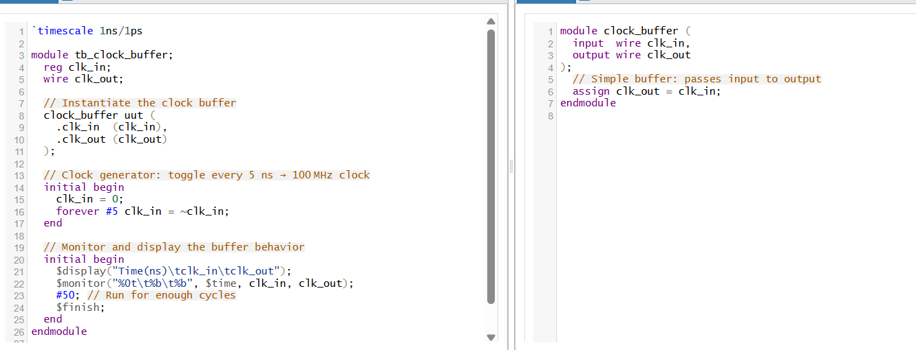
OUTPUT:
KERNEL: Time(ns) clk_in clk_out
# KERNEL: 0 0 0
# KERNEL: 5000 1 1
# KERNEL: 10000 0 0
# KERNEL: 15000 1 1
# KERNEL: 20000 0 0
# KERNEL: 25000 1 1
# KERNEL: 30000 0 0
# KERNEL: 35000 1 1
# KERNEL: 40000 0 0
# KERNEL: 45000 1 1

🧠 What is a Clock Buffer?
A clock buffer is a specialized buffer designed to drive and distribute clock signals across a digital system or FPGA. Unlike general-purpose buffers, they ensure that the clock signal remains strong, has minimal skew, and maintains a stable duty cycle
🔍 Why Use Clock Buffers?
- High Fanout Drive
Clock nets often connect to thousands of flip-flops. These nets require high-drive buffers to prevent signal degradation and loading issues
- Low Clock Skew
Skew (timing differences between clock arrivals) can cause timing violations. Clock buffers—often forming a carefully balanced "clock tree"—minimize skew across different regions.
- Even Rise/Fall Times
They ensure balanced transitions, maintaining a clean 50:50 duty cycle which regular buffers often cannot
- Signal Conditioning and Routing Layers
Clock buffers often use higher metal layers and larger transistors to preserve signal integrity and match timing requirements.
✅ Summary Table
Feature | Clock Buffer | Standard Buffer
Drive Strength | Very high (for large fanout) | Lower – for small loads
Rise/Fall Times | Precisely matched (duty cycle preserved) | Varying rise/fall characteristics
Skew Control | Specifically optimized for low skew | No timing guarantees
Usage Area | Clock distribution trees/networks | General data/control signal use
Day 55: Synchronous FIFO
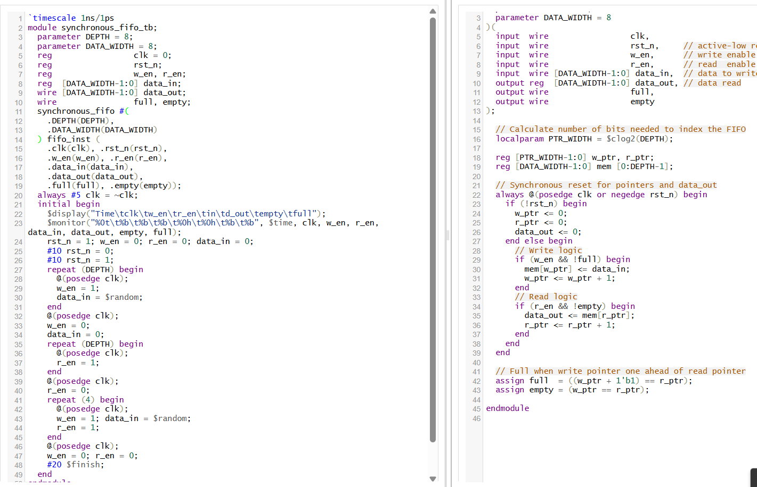
output
KERNEL: Time(ns) clk_in clk_out
# KERNEL: 0 0 0
# KERNEL: 5000 1 1
# KERNEL: 10000 0 0
# KERNEL: 15000 1 1
# KERNEL: 20000 0 0
# KERNEL: 25000 1 1
# KERNEL: 30000 0 0
# KERNEL: 35000 1 1
# KERNEL: 40000 0 0
# KERNEL: 45000 1 1
🧠 What Is a Synchronous FIFO?
A synchronous FIFO is a first-in-first-out buffer where both read and write operations share the same clock domain. This ensures simplified timing and control, since both pointers and flags update synchronously with every clock pulse
🧱 Components & Operation
- Memory Array
Internally you’ll find a storage array (e.g., mem[0:DEPTH-1]) for buffering data.
- Write and Read Pointers
Each pointer tracks the location for the next write (w_ptr) or read (r_ptr), and increments on each valid operation
- Circular Buffer Behavior
These pointers wrap around upon reaching the end, forming a circular structure. The modulo arithmetic ensures smooth wrap-around without resetting the FIFO
- Full and Empty Flags
  - A FIFO is empty when w_ptr == r_ptr, meaning no data is available
  - A FIFO is full when a write would cause w_ptr + 1 == r_ptr. That extra address condition helps differentiate between empty and full if only equal pointer values were used .
A more hardware-efficient method uses one extra bit in the pointer (making it PTR_WIDTH + 1), where MSB toggles on wrap-around:
  - Then empty: full pointer equals read pointer.
  - Full: only LSBs equal, MSBs differ

📐 Why Use Synchronous FIFO?
- Timing Simplicity: Everything happens in the same clock domain—no worry about metastability or CDC issues that asynchronous FIFOs require

- Predictable Performance: Synchronous logic supports high clock frequencies and simpler timing closure in FPGAs or ASICs

- Reliable Flow Control: Full and empty flags are generated cleanly since they update synchronously with pointer increments

Day 56: Priority Encoder
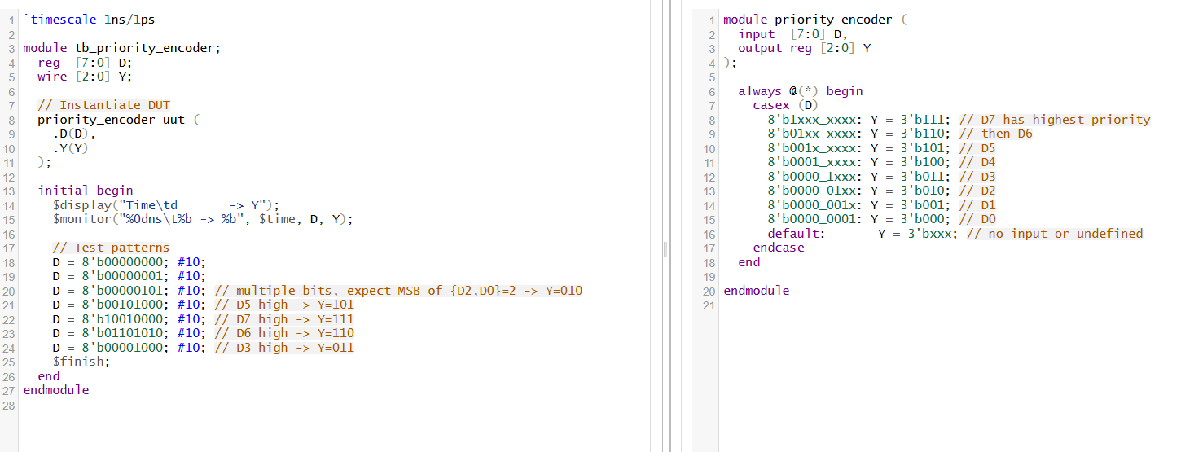
output
# KERNEL: Time d -> Y
# KERNEL: 0ns 00000000 -> xxx
# KERNEL: 10ns 00000001 -> 000
# KERNEL: 20ns 00000101 -> 010
# KERNEL: 30ns 00101000 -> 101
# KERNEL: 40ns 10010000 -> 111
# KERNEL: 50ns 01101010 -> 110
# KERNEL: 60ns 00001000 -> 011
🎯 What Is a Priority Encoder?
A priority encoder is a combinational logic circuit that takes multiple inputs (typically one-hot or sparse) and outputs a binary code of the highest-priority input that is asserted
Unlike a basic encoder—which assumes at most one input is active and can produce incorrect outputs when multiple inputs are active—a priority encoder handles conflicts by always selecting the input with the highest designated priority, usually the largest index .

⚙️ How It Works
- Inputs: N signals (e.g., D₀–D₇ for an 8:3 encoder)
- Output: Log₂(N)-bit binary code (e.g., 3 bits for 8 inputs)
- Priority Logic: If multiple inputs are active simultaneously, only the input with the highest priority (i.e., MSB first) is encoded
🛠️ Truth Table Example (4-to-2 Priority Encoder)
I₃ | I₂ | I₁ | I₀ | Output (O₁O₀) | Valid
0 | 0 | 0 | 0 | — | 0
0 | 0 | 0 | 1 | 00 | 1
0 | 0 | 1 | X | 01 | 1
0 | 1 | X | X | 10 | 1
1 | X | X | X | 11 | 1
The Valid signal indicates when at least one input is asserted, avoiding ambiguity when all inputs are zero .
✅ Benefits Over Simple Encoders
- Robustness: Correct outputs even when multiple inputs are active.
- Determinism: Encodes only the highest-priority input, eliminating output ambiguity .
- Useful flags: Often include a valid or enable signal to indicate if the input is meaningful .

Day 57: N-Bit Comparator
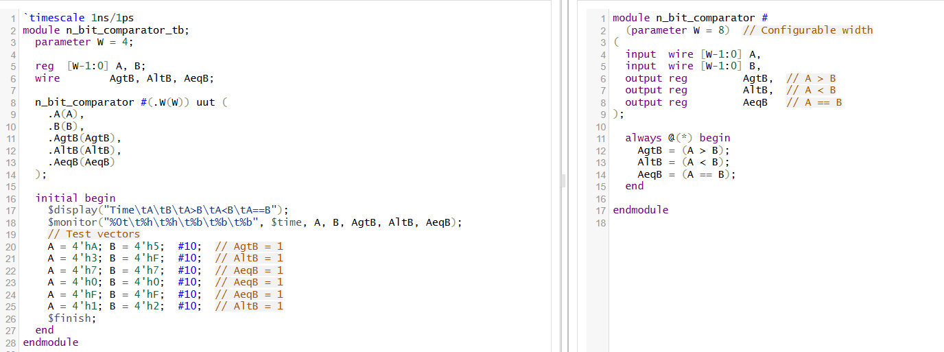
OUTPUT
KERNEL: Time A B A>B A<B A==B
# KERNEL: 0 a 5 1 0 0
# KERNEL: 10000 3 f 0 1 0
# KERNEL: 20000 7 7 0 0 1
# KERNEL: 30000 0 0 0 0 1
# KERNEL: 40000 f f 0 0 1
# KERNEL: 50000 1 2 0 1 0
🛠️ Fundamental Building Blocks
- 1-Bit Comparator
  - Compares single bits A₀ and B₀:
    - A > B: A·B′
    - A < B: A′·B
    - A = B: A⊙B (XNOR)
- n-Bit Scaling – Cascading Technique
  - To build an n-bit comparator:
    - Compare most significant bits (MSBs) first.
    - If they're unequal, that determines A > B or A < B immediately.
    - If equal, proceed to the next bit.
  - If all bits match, then A = B This cascading structure is fundamental and also used in comparator ICs like TTL 7485
⚙️ Logical Equations for n-Bit Comparator
Assume A = Aₙ₋₁…A₀ and B = Bₙ₋₁…B₀:
- A = B:
EQ = ∧(Aᵢ XNOR Bᵢ) for i = 0…n−1
- A > B:
There exists a highest position k such that Aₖ = 1 and Bₖ = 0, and for all higher bits (j > k), Aⱼ = Bⱼ.
In logical form:
GT = (Aₙ₋₁·Bₙ₋₁′) + (EQₘₛb·Aₙ₋₂·Bₙ₋₂′) + … + (EQ_all_higher·A₀·B₀′)
- A < B is similarly derived (flip roles of A and B).

💡 Key Advantages
- Efficient and Predictable: Especially useful in ALUs, address comparators, interrupt controllers. They provide quick decisions based on MSB-first logic
- Scalable Architecture: Built modularly from 1-bit comparators or cascaded 4-bit blocks with external logic to scale to any width

Day 58: 7 segment Display Using ROM
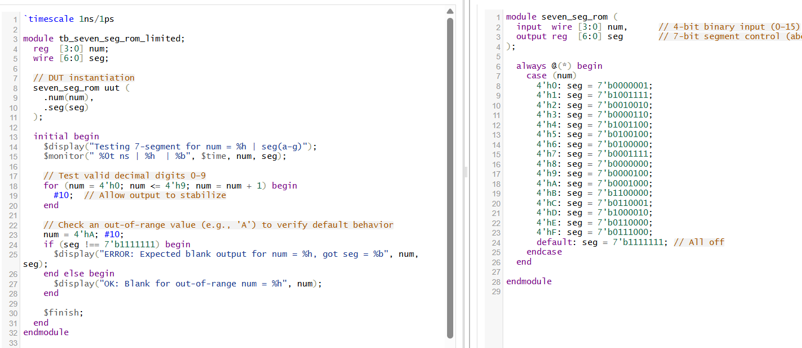
OUTPUT
KERNEL: Testing 7-segment for num =
# KERNEL: 0 ns | 0 | 0000001
# KERNEL: 10000 ns | 1 | 1001111
# KERNEL: 20000 ns | 2 | 0010010
# KERNEL: 30000 ns | 3 | 0000110
# KERNEL: 40000 ns | 4 | 1001100
# KERNEL: 50000 ns | 5 | 0100100
# KERNEL: 60000 ns | 6 | 0100000
# KERNEL: 70000 ns | 7 | 0001111
# KERNEL: 80000 ns | 8 | 0000000
# KERNEL: 90000 ns | 9 | 0000100
# KERNEL: 100000 ns | a | 0001000

✨ Core Concept: BCD to 7-Segment Decoder
- A 7-segment display comprises seven individual LEDs (segments labeled a to g) arranged to show decimal numerals (0–9).
- A BCD-to-7-segment decoder takes a 4-bit BCD input (0000=0 to 1001=9) and outputs seven control signals, one for each segment, activating LEDs to form the corresponding digit
- Inputs 1010–1111 are invalid for decimal display and typically mapped to blank outputs or ignored .

🔄 Decoder Logic
- Truth Table Construction
  - Define which segments light up for each BCD digit (0–9).
  - For example: to display “0”, segments a, b, c, d, e, f are on while g is off.
- Logic Simplification
  - Use Karnaugh maps to derive minimized boolean expressions for each segment output function.
  - Expressions generate control signals efficiently with minimal gates.
- ROM-Style Implementation
  - Instead of discrete gates, a compact and synthesizable method uses a lookup table implemented via a case or indexed array.
  - This directly maps 4-bit inputs to 7-bit segment patterns—simple and flexible.
Day 59: Fixed Priority Arbiter
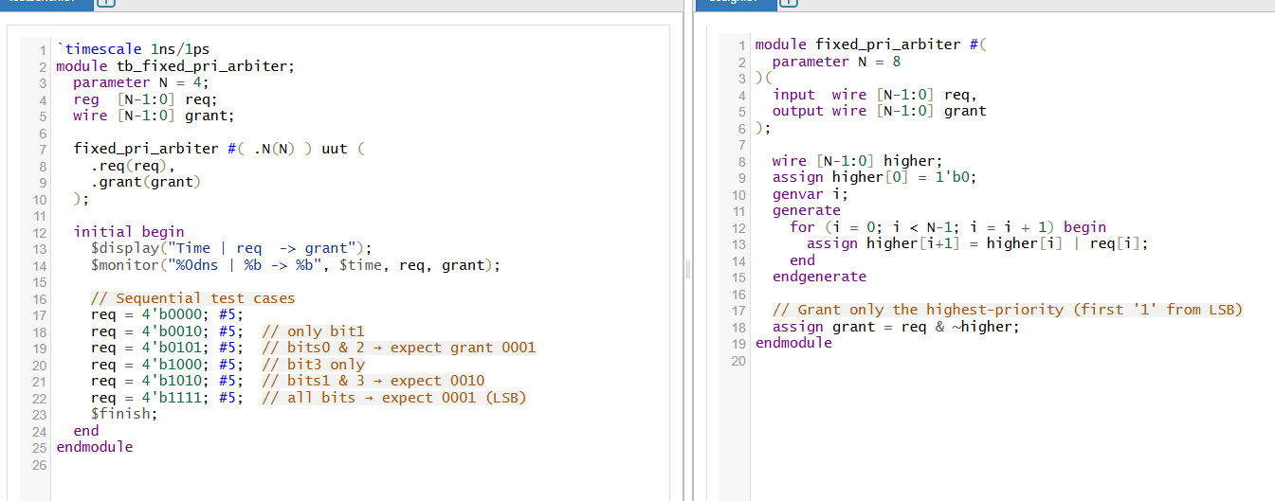
KERNEL: Time req -> grant
# KERNEL: 0ns | 0000 -> 0000
# KERNEL: 5ns | 0010 -> 0010
# KERNEL: 10ns | 0101 -> 0001
# KERNEL: 15ns | 1000 -> 1000
# KERNEL: 20ns | 1010 -> 0010
# KERNEL: 25ns | 1111 -> 0001
🎯 What Is a Fixed-Priority Arbiter?
A fixed-priority arbiter is a digital circuit that manages access to a shared resource (e.g., bus, memory) when multiple clients may request it simultaneously. It selects one requester based on a predefined static priority order—granting access to the highest-priority request line that is asserted at that moment
⚙️ How It Works
- Request Vector (req)
Each bit represents a client’s request. For an N-bit arbiter, you have N clients.
- Priority Encoding
The arbiter uses a priority encoder-like structure that identifies the first asserted bit according to priority rules (commonly LSB = highest priority or MSB = highest priority).
- Grant Output (grant)
Only one bit is asserted in a one-hot grant output, indicating which requester is given access. Lower-priority requests are ignored if a higher-priority one is.
🔍 Fixed-Priority vs Other Schemes
- Fixed Priority: Simple and fast—resolves contention in a single combinational pass .
- Drawback: May starve low-priority clients if high-priority clients frequently request
- Alternatives:
  - Round-Robin Arbiter: Rotates priorities to ensure fairness.
  - Dynamic Priority: Adjusts priority based on history or other factors.
🛠️ Implementation Details
- Use a prefix OR chain to detect if any higher-priority bit is set.
- The grant for each position i is asserted only if req[i] is high and no higher-priority request is active.
- This is efficient and scales well for any number of requesters by parameterizing the logic
- ✅ Applications & Trade-Off Analysis
Aspect | Fixed-Priority Arbiter
Use Cases | Bus arbitration, memory access control, interrupt handling
Benefits | Fast, simple logic, easily synthesizable
Limitations | Potential starvation of low-priority requesters
Alternatives | Round-Robin (fair), dynamic priority (adaptive fairness)
Day 60: Round Robin Arbiter
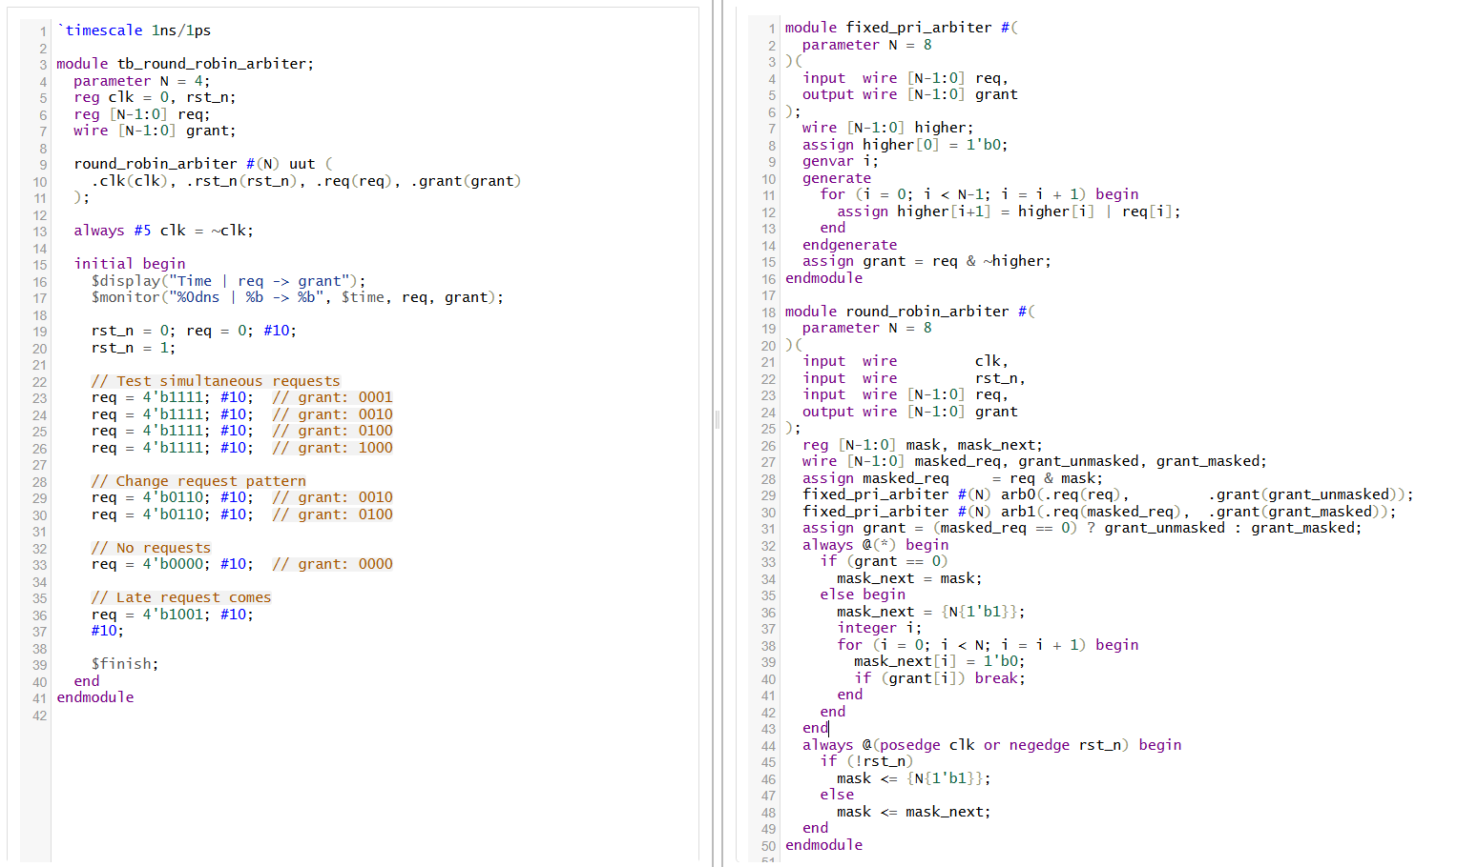
KERNEL: Time | req -> grant
# KERNEL: 0ns | 0000 -> 0000
# KERNEL: 5ns | 0010 -> 0010
# KERNEL: 10ns | 0101 -> 0001
# KERNEL: 15ns | 1000 -> 1000
# KERNEL: 20ns | 1010 -> 0010
# KERNEL: 25ns | 1111 -> 0001

🎯 What Is a Round-Robin Arbiter?
A round-robin arbiter ensures fair and bounded access to a shared resource by cycling through requesters in a fixed order. Unlike fixed-priority arbiters that can cause starvation, round-robin guarantees that each requester will eventually receive service

⚙️ How It Works
- Mask-Based Priority Rotation
After each grant, the arbiter updates a mask so that the next requester in sequence becomes the first to be considered. This mask rotates continuously, preserving shared fairness
- Dual Arbiter Mechanism
The logic uses two fixed-priority controllers:
  - One scans all active requests directly.
  - The other uses the masked requests to respect the current priority rotation.
The final grant is based on whichever arbiter (masked or unmasked) produces the active request No Starvation Guarantee
Every requester will get service in a predictable round-robin sequence, even if others stay active.

⭐ Key Advantages
- Fairness: Requests are honored in sequence, with no single requester dominating.
- No Starvation: Each band gets guaranteed turns—unlike fixed-priority systems where low-priority can be denied indefinitely.
- Efficient Hardware: Builds on existing priority encoder logic with minimal overhead

🧩 Use Cases
- Ideal in scenarios where every client must be guaranteed access, such as network routers, bus controllers, or multi-client shared memory systems.
- When simple yet fair arbitration is needed without tailored priority managemen



